Cats and Dogs CNN
  - Manual hyperparameters and Keras Tuner comparison

Objective and baseline
Train a CNN to distinguish dogs from cats and compare hand-selected settings with an automated Keras Tuner search. The executed baseline uses 128 x 128 grayscale images, normalized pixels, Conv2D filters 2/64/64 with 3 x 3 kernels, 2 x 2 max pooling, Flatten, two linear Dense(64) layers and one sigmoid output. Adam uses learning rate 0.001, binary cross-entropy, batch size 128 and five epochs.
Earlier notebook evidence: cell 33 defines the model; cell 35 records the five training epochs; cell 36 contains plots and predictions. Final training accuracy was 79.67%, final validation accuracy 77.62%, and final validation loss 0.4952. The best validation accuracy was 78.16% at epoch 4, with loss 0.4792. These historical scores use a different unseeded split and are contextual. Predictions on the full original image array are not independent test evaluation.

Controlled experiment
Dog = 0 and Cat = 1. Unreadable images are excluded and exact duplicate file bytes removed before a seed-42 stratified split: 64% training, 16% validation and 20% test. OpenCV grayscale conversion and resizing match the original preprocessing. Three manual configurations are selected by minimum validation loss. Keras Tuner RandomSearch evaluates eight configurations with the same per-model epoch limit and batch size. Both methods retain their best validation-loss checkpoint; the tuner configuration is retrained before comparison. Test images are used only for final evaluation.

Hyperparameter comparison
Setting | Original manual | Automated search
First Conv2D filters | 2 | 2, 16, 32, 64
Second/third filters | 64 / 64 | 64 / 64 (fixed)
Shared kernel | 3 x 3 | 3 x 3 or 5 x 5
Two dense widths | 64 / 64 | 64 / 64 or 128 / 128
Dense activation | Linear | Linear or ReLU
Dropout | 0 | 0, 0.25, 0.50
Adam learning rate | 0.001 | 0.0001 or 0.001
Batch / epochs | 128 / 5 | 128 / 5 by default
Manual alternative 1: first filters 32, dense widths 64, ReLU dense activation, dropout 0.25, learning rate 0.001. Alternative 2: first filters 64, dense widths 128, ReLU, dropout 0.50, learning rate 0.0001. Both use 3 x 3 kernels. These are hand-selected trials, not previously measured outcomes.

Results and interpretation
Dataset: User-supplied PetImages (Dog/Cat folders). Valid unique images: 24,965. Split counts: train 15,977, validation 3,995, test 4,993. Epoch limit: 5. Batch size: 128.
Selected manual configuration: {"name": "Manual wider first layer", "filters_1": 32, "kernel_size": 3, "dense_units": 64, "dense_activation": "relu", "dropout": 0.25, "learning_rate": 0.001}
Selected Keras Tuner configuration: {"filters_1": 32, "kernel_size": 3, "dense_units": 64, "dense_activation": "linear", "dropout": 0.5, "learning_rate": 0.001}
Metric | Manual selected | Keras Tuner selected
Best epoch | 5 | 5
Parameters | 862849 | 862849
Training accuracy | 0.8674 | 0.8242
Training loss | 0.3101 | 0.3867
Validation accuracy | 0.8110 | 0.7905
Validation loss | 0.4161 | 0.4612
Test accuracy | 0.8234 | 0.7889
Test loss | 0.3974 | 0.4561
Macro precision | 0.8234 | 0.7984
Macro recall | 0.8234 | 0.7889
Macro f1 | 0.8234 | 0.7872
Roc auc | 0.9020 | 0.8805
Keras Tuner changed validation accuracy by -2.05 percentage points and validation loss by +0.0451 relative to the selected manual CNN. The unseen-test accuracy difference was -3.44 percentage points. The direction and magnitude come from this run; automated tuning does not guarantee improvement. The search covers eight configurations versus three manual configurations, so total search budgets differ.
Manual selection time: 436.1 seconds; tuner search time: 1050.3 seconds; tuned final fit: 138.5 seconds. Each candidate uses the same epoch budget, but the automatic search has more trials.
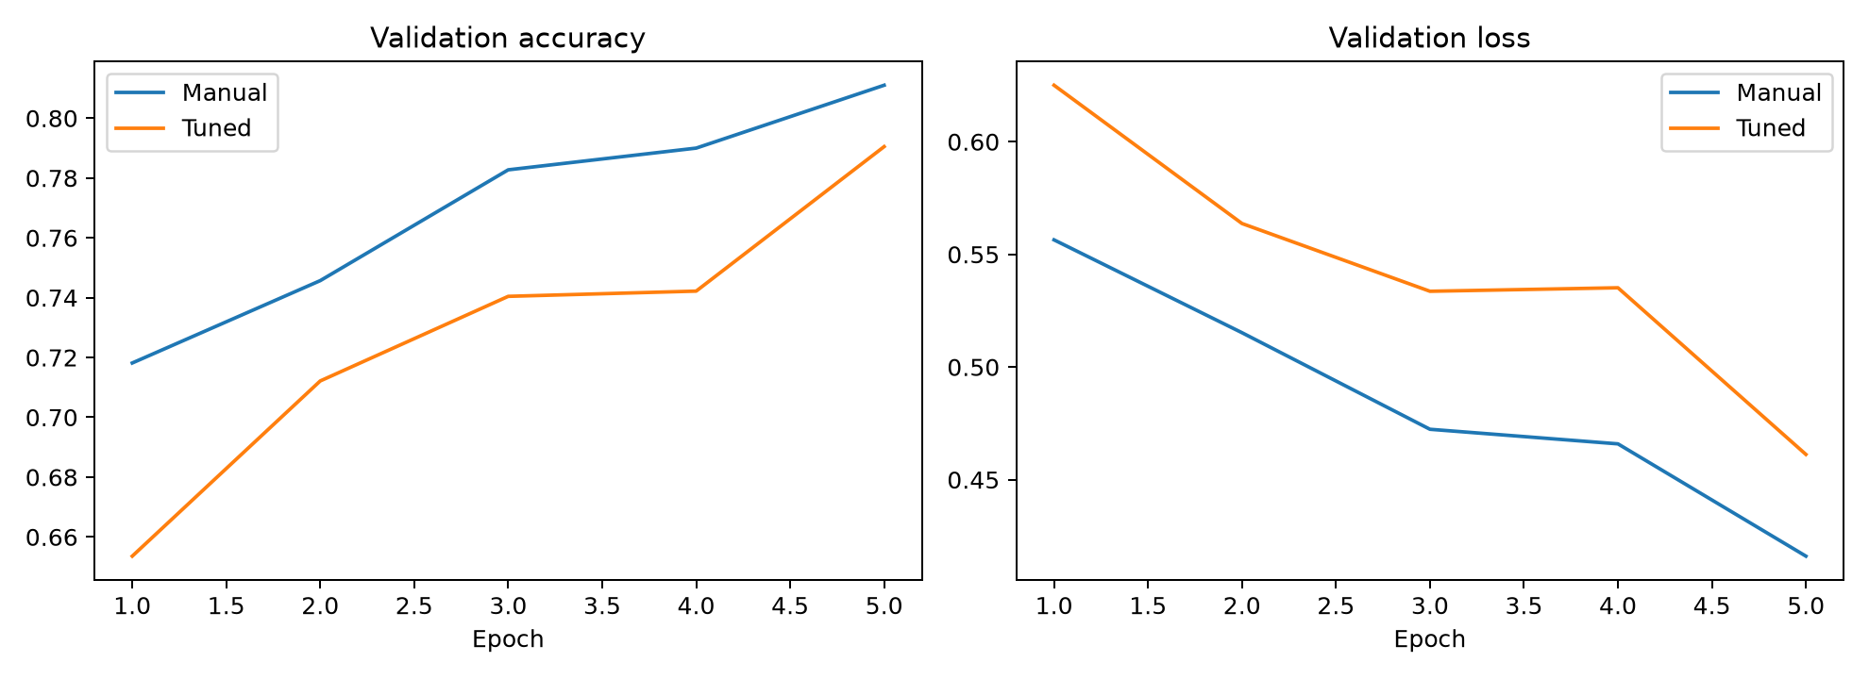
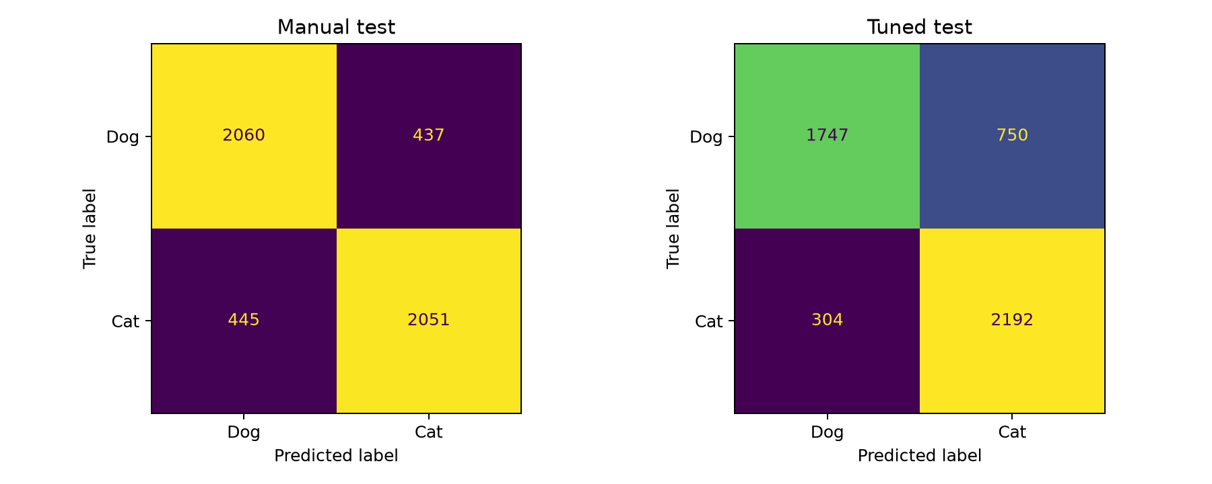
Report validation accuracy and loss separately: minimizing loss need not maximize accuracy. A positive accuracy difference indicates an improvement in that metric. Review test macro precision, recall, F1 and AUC alongside accuracy. This single-seed experiment cannot establish a statistically significant advantage. Duplicate-byte removal does not detect visually similar images or every potential source of leakage.

Execution and GitHub submission
Open CNN_Cats_Dogs_Keras_Tuning.ipynb in Colab or VS Code. Install dependencies, choose a GPU where available, set DATA_DIR, and run all cells. The final cell generates CNN_Cats_Dogs_Comparison.docx, comparison.csv, tuner_trials.csv, plots and environment details. Save the notebook with all training outputs. In a public course repository, create a folder such as CNN-Hyperparameter-Tuning and upload the executed notebook and generated .docx. Submit the folder URL. Dataset images, cached arrays and trained models need not be uploaded.

References
Earlier course notebook: Loading_Dataset_and_CNN_(2).ipynb, cells 33-36; manual selection form: MANUAL HYPERPARAMETER SELECTION FORM (1).docx.
Keras Team. Getting started with KerasTuner. https://keras.io/keras_tuner/getting_started/
TensorFlow. Transfer learning and fine-tuning (filtered cats-and-dogs dataset source). https://www.tensorflow.org/tutorials/images/transfer_learning
Dataset used previously: Kaggle Dogs vs. Cats / PetImages; supply the same local dataset for the rerun. https://www.kaggle.com/c/dogs-vs-cats/data

